**Guess the Murderer Game**

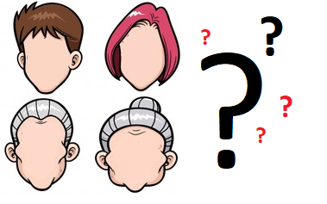

**Project for**

**Information Systems D: Declarative Problem-Solving Methods Course**

**27th September 2018**

**Biomedical Center (BMC) Group:**

Mikhail Boronin

Hongyu He

Wafaa Elbaghdady

**Table of Contents**

1. Project Plan 3

2. Programming Manual 4

2.1 Program Purpose 4

2.2 Program Structure 5

2.3 User Interface 6

2.4 Program Code 8

2.5 Testing 9

3. User Manual 11

1. Project Plan

|  |  |  |  |  |  |
| --- | --- | --- | --- | --- | --- |
| **Task** | **Assigned to** | **Start Date** | **Finish Date** | **Work (in hours)** | **Notes** |
| Group meeting to discuss project components, strategy and roles | MB, HH, WE | 11-sep | - | 1 |  |
| Introduce a number of tools to help in planning, sharing and implementation | MB | 11-sep | 11-sep | 1 | GitHub, Trello, draw.io, OneDrive |
| Prepare project plan | WE | 12-sep | 14-sep | 3 |  |
| Write program purpose | MB, HH, WE | 12-sep | 14-sep | 3 |  |
| Prepare program structure | WE | 12-sep | 14-sep | 3 | diagram/flowchart using draw.io tool |
| Prepare UI description | HH | 12-sep | 14-sep | 3 |  |
| Write program code | MB | 14-sep | 19-sep | 6 |  |
| Write testing report | MB | 14-sep | 19-sep | 4 |  |
| Write user manual | HH, WE | 14-sep | 19-sep | 4 |  |
| Prepare report structure | WE | 16-sep | 16-sep | 2 |  |
| Group meeting to review project plan, purpose, structure, UI description | MB, HH, WE | 14-sep | - | 1 |  |
| Group meeting to review the code and testing report | MB, HH, WE | 17-sep | - | 1 |  |
| Project meeting to show progress | MB, HH, WE | 21-sep | - | 1 | code, draft project plan, program purpose and structure |
| Group meeting to review the code and testing report | MB, HH, WE | 25-sep | - | 1 |  |
| Review and finalize the report | WE | 25-sep | 26-sep | 4 |  |
| Meet with opponent group to understand their project and explain ours | MB, HH, WE | 24-sep | 25-sep | 2 |  |
| Project submission on student portal | MB, HH, WE | 27-sep | - | 1 |  |
| Prepare opposition report | MB, HH, WE | 27-sep | 27-sep | 4 |  |
| Group meeting to finalize the report and prepare for presentation of opponent group | MB, HH, WE | 27-sep | - | 1 |  |
| Presentation of opponent group | MB, HH, WE | 28-sep | - | 1 |  |

|  |  |
| --- | --- |
| **Group Members** | **Initials** |
| Mikhail Boronin | MB |
| Hongyu He | HH |
| Wafaa Elbaghdady | WE |

1. Programming Manual
   1. Program Purpose

The game is about finding the murderer who committed the crime. The player will be given random clues until he/she is ready to guess who the murderer was. Every clue is a combination of features describing either a suspect or an innocent person.

A suspect has at least one feature that matches the features of the murderer, while an innocent person has nothing in common with the murderer.

The features are age/gender, colour of clothes and weapon used in the murder. To guess the murderer, the player should give the value of the three features and if they all match the murderer description, the player wins. The challenge is to give a guess with the least number of suspects and innocents displayed during the game as clues.

* 1. Program Structure

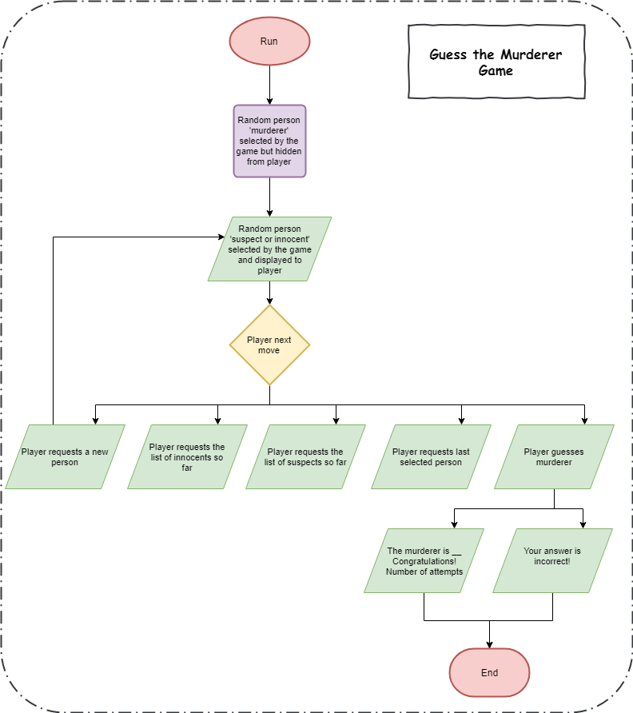

* 1. User Interface

1. **Rule Introduction**

output: ‘Rule introduction - A person was murdered, and the murderer is unknown until the end of the game. Each person has a unique combination of attributes. You can make a guess of the murderer with his/her attributes. Before guessing you can ask for random clues which will show attributes of a person and whether he/she is suspect or innocent. A person is considered a ‘suspect’ if at least one attribute matches those of the murderer. A person is considered an ‘innocent’ if no attributes matches the murderer’s. Clear now?

Yes, I get it! - Select 1.

No, I haven't known the rule clearly. - Select 2.’

if input: ‘1.’

Go to 2.1.

else if input: ‘2.’

output: ‘We can´t continue the game for now, read the manual once again’

else output: ‘Incorrect Input, try again: ’,

Go to 1.

1. **Functions**

**2.1 Functions catalogue**

output: To ask for a new clue - Select 1.

To guess the murderer - Select 2.

To view the last clue - Select 3.

To view all suspects - Select 4.

To view all innocents - Select 5.

To exit the game - Select 6.

if input: ‘1.’

Go to 2.2.

else if input: ‘2.’

Go to 2.3.

else if input: ‘3.’

Go to 2.4.

else if input: ‘4.’

Go to 2.5.

else if input: ‘5.’

Go to 2.6.

else if input: ‘6.’

Go to 2.7.

else output: ‘Incorrect Input, try again: ’,

Go to 2.1.

**2.2 To ask for a new clue**

if there are new clues can be given

output: ‘[A,C,W]-M',

Go to 2.1.

else output: ‘No more clues left’,

Go to 2.1.

**2.3 To guess the murderer**

**2.3.1 To give a guess in age&gender**

output: ‘Input the first parameters for your guess. Available options are: …. Type below’

if input: age&gender in the list

Go to 2.3.2.

else output: ‘Incorrect Input, try again: ’,

Go to 2.3.1.

**2.3.2 To give a guess in colour**

output: ‘Input the second parameters for your guess. Available options are: …. Type below’

if input: colour in the list

Go to 2.3.3.

else output: ‘Incorrect Input, try again: ’,

Go to 2.3.2.

**2.3.3 To give a guess in weapon**

output: ‘Input the third parameters for your guess. Available options are: …. Type below’

if input: weapon in the list

Go to 2.3.4.

else output: ‘Incorrect Input, try again:’,

Go to 2.3.3.

**2.3.4 Compare guess with murderer**

If the guess is right

output: ‘Congratulations! You were right! The murderer is …. You have used ... number of clues. We are ending the game now. See you next time!’

else output: ‘You lost! The murderer is …. You have used ... number of clues. We are ending the game now. See you next time!’

**2.4 To view the last clue**

if there is shown clue

output: [A,C,W]-M,

Go to 2.1.

else output: ‘You have not used any clues so far’,

Go to 2.1.

**2.5 To view suspects so far**

if there is shown suspect

output: ‘All the checked suspects are here: …',

Go to 2.1.

else output: ‘The were no shown suspects so far’

Go to 2.1.

**2.6 To view innocents so far**

If there is shown innocent

output: ‘All the checked innocents are here: …',

Go to 2.1.

else output: ‘The were no shown innocents so far’

Go to 2.1.

**2.7 To exit the game**

output: ‘The murderer is …. You have used ... number of clues. We are ending the game now. See you next time!’

Click here to view [Input and output diagram.](https://www.draw.io/?lightbox=1&highlight=0000ff&edit=_blank&layers=1&nav=1&title=Input%20and%20output%20Diagram(latest).xml#R5V1bl6K4Fv4t58HVT%2B2S3MDHqpqey0PPmnX6nNXTj7RSymqEGsCuqvPrTwIEYScIKGDUerA0YsTv29nZtyQz%2FLR7%2By12X7afo7UXzNBi%2FTbDv8wQQhQx%2Fk%2B0vOcthKK8YRP767zJOjR88f%2FnFY2LonXvr72kdmEaRUHqv9QbV1EYequ01ubGcfRav%2Bw5Curf%2BuJuPKXhy8oN1Nav%2Fjrd5q0Osg%2Ftv3v%2BZiu%2F2WLL%2FJ3v7urHJo72YfF9M4Sfs7%2F87Z0r%2Byp%2BaLJ119FrpQl%2FmuGnOIrS%2FNnu7ckLBLYStvxzvza8W9537IVplw%2FQ%2FAM%2F3WBf%2FPRon77s%2BWcfePOHf%2B85IvzqMEnj%2FSr1o3A%2Bn38obj19l3BlP9gTXS5m%2BPF166felxd3Jd595QLC27bpLuCvLP5UvcXirn96ceq9VZqKW%2F7Ni3ZeGr%2FzS4p3PzKrkKd3KTcFnq8HtiyJ8bbCFCna3EJANmXfB5D4kwInPWbL45h9FYit3PBDmgto6od70ZRuxePG3XmZRMb8MeTUI%2F59i9hz1%2BUlOzfcu%2BILo3AlXrsb1w9NRB0taDfU7QFQl6qhCfY%2FwlUUx0IZoMUfoWjPkM1%2FgTEQ4iWAEE0ouBZRIFQQ8cL1g1Cg%2FNUqcJPEX9VB4L89fv9bADan8uW3Aj%2FvzU8rb%2FFX39qgS6J9vPJquih1441XXIWkXvXWNYWtAlzBj2rgk22xF7ip%2F7Ou5nWYFt%2FwV%2BSHaZU%2Fy67xhzHgJf9Bxceqihf2ZON6T6UkyJ5yHJSeMpLLH96Nd1XLG867aazXJxs4FjtzjgjgHErPgJyza%2BNcKvgbI92u9zMm5XYvysMo5I2PazfZZjOg1Ui%2BfYR9%2B1bpRwyMVefUUd86ZwwnAqVFchABPzzYSJbGBOKWS1pnntv60Q%2FvKQq4jVqKybMfBKDJDfxNKHQHZ9rj7Y%2FCDvK5E%2FVQvLHz12vxNVrDqm56NUpND9vKpnWcLUe1rZhGYuDEe4ppJYdaA%2FDopoFXvLEpgcfHgJ8h5u7Ejw6%2FJ%2BKfFyTeDRNBbDAClioR9lhEsON%2B8fM%2BzAIIM%2BEcp24QbfYqFZP7Y%2FaywQqfwh9Dtqquaz4tF99AiGby4grcAjfcZFexf%2FYiQPT46c%2BP%2F%2F1yeMmfbcT%2Fwv0twgnPfpykOVAuv0UvTmYy%2FvDOp7CZiLZ5SVL%2Frryj%2BXwum%2Flvqb7T0GyAh21hMA1gB6uUWjpK7SEodY5TWucm8VZRuG4nx4yomwItldNeG7Qy%2FHsetC2Bt0FGS7r14w6E3OxoYVKAJ6FUGgrnBfVycL%2FHB7gvDitawJHSEdZB5hWnZV65GVg7S%2BswsKpGfg3WpyjcxG66F45nFCb%2F4m3for24Oy8WuiUW9yNaDVHnhNTt9qWMu7WiSYdAU7Xca2jm0AVRYhJkiAHIMJtrkiA60KDXfxpoagj%2FNke2ozPERxvZS9VqUzBpjZY2RkSPxVEbwauGy0rTp5YbkbJgSsTMQiC5ZctJr3fIzLJQvSsHg66Gi5nhhTpbHiO%2FLW6qD40ujoVUO8dNS85rgiClwxxBoKTOHjlZEGBX9piCoM7vl9YCZvNcIiatXHYyz7Cr0rIbg2fV8rg0z3Vt7%2Bi0vWUY%2BVDbU8hYj0EOumLOiOT3S4ZfVttrtYBjmiAwcpy9HoIAulJkakhBGCJDfl4WvAwAm8PlcINamRygNTgkl%2F1S39NrdN1AlsEvc8h3AGNnDGTQFVuOSL4aFzZXoy90Gt04LQDVMDS6T9foBOPRBKGtRHRGH%2Fn%2FJ97R09cZ%2FeXjZxMiSgsLRoqL1xWyHV3cAzXz2jXugWXivgmxh%2BzyPDOy2nqrHxwajtc%2BefFWqciMuFlgcyvim%2FjBjBidbV8wSYWtlqjmiUmq%2F2QUFHHkMBIQb6NX0YMfhpGoP0gyVcMfnt3Y3HwTdi5KzrCFsITUzYH5ApUNf3mxn%2BUP5dxxpqXIdBFA0yYOBwMD4vTqaGA%2FEFh9N%2BS00c9%2BmNx41FFPbcOMRxvE79HyVOotWqce0%2FGoR6rFMCD1%2Feg1hUmrtEAkAWw5p6eTCatxRmRTtWZ6s9nIWXX0YWRa6qUV5h6MgUUKBGbYhmSsJZ15orWkq86ZfUIzDgr3Q6EXcH1FOxSauHKebanzxKxZsjobUW1rRkfhrBdFfwozeBdltvKK36QwjQPvOT2TumoB8AzhX7O%2FwWoxFMN4wsoWjEZeLdQburq2pTesbRmdEyp6WIpHC4zr8aJmaNjVQs1Rs0aOq1aQeTMqA%2BszrQVcxWymEYT7mbSn89p7TNf5Nm5MExjzRFdB9xTFK1fszCyWLYvvDKV11JhENy6NKzcZsL4MJiedEZ0cMkSQ4eziIRlQM4ZNDCs%2BT15Wb2EpqrCQeQw2%2ByncsdjEhrGJloOxicBy0iW2x2NTdXw0Rehb92eedxH3uU%2ByJJgbCnileykzLwa7mEtlSUoB8ySpFzKFu3G9dgqD61BPdjaWIDaEYU9Djp5Ry%2Bavk0kbXSWTQ9ib585q2LQ9QFoZ6FMQ5dS6IgsyGpnUBIOznFpvkUwbkGmNSCaaYOLsHqczjVVG66a%2FUihgpLql%2FVYgjE2qaXqXEUDqycUEk5LaksxsruGqFNQN5Eg08t5nWx9ySYeBjpNm1Fc0VovoYEmjuXlgqpSOdiQILsc7jSAD1k%2BYZvwv2VCJQehGjKq4hlg9cb7xj8zispWB7lzCDQBHTBzQIVzys7mUU%2BEtconqOnfEFD0dwim%2FMQ0L60zxyaYhgZnBETUsM8Ijp4bl3FsZ6M6lM52GZSYkgMp1JjfIJaj%2FVgoxhuQS9eJydD%2FcMBPIkXGts9cBTmnOMrOCK6bZQsy5SlLV4MpFSTVsKmU2IPXkHXcmNYum2oujo%2Fo1bE5lcBk2vQpS%2B8WFTj2GoPNiHfNcmMGcUQbMXmKNSOs0p0tcL63DWcCtxSDD0Uo0dTn3c2KERUBFKSZEs53nWGcXEE39zP2cGmGV6zXLhb7Tgq9G16rg49sGfwHBn1byNSUqVfDJTYMPD53AeFrs1QBWFXt609hTiP3Eco%2BOYs9uGnuCIfb2pNircaF0m1dj5Dn%2F0HudHUq6V1ldwffs0FZuFoYdts2%2BHaosBvIsRHOU0HhMqcEeyZQvqMmKZw5s3Rcz9KLMqBGbiv4Sp2rLE7fyxw13CTlqosJmJstuAj9Jb5kgDM4ImJYgNfpSISg%2F%2F%2ByeRgs8cpVqTgofj4yjzvWKQ7e%2Ft7EB6jEZUemw6Vh0HHW373Fs1BUVo1OOjaPu96vnvkThvY2Ncp8tuYhSo6x0e4EOQoimRuW%2BRwfwVnRkjDY6NDnsfBAUp8%2FldnB2oNR9sULAFpNOx7Nm5YYKZ7Fit%2Fglsp7%2F%2FpySBchpEbsbLUPsXkVs1SlR3cW75WaJL%2Bgv2qo7oh0xxQqYuyKmcY%2FbSYhRXZPmMXOP7DD7ksNG9VS0w0auW7orZiiqW8lE7po3CTOq29I8bu6SHoLqVUtTDpxyW%2BzjazB3%2B3jNOctiL4acrY3hyjGqy41oD4IYYFNXaqPjuHU7V%2FTSIFoQRLbQnc6KRjJEqW34wXL6neSLezSljko5OhsWtfXYsQ9M4Qz0NFwdFdW4hkr05GZVPgyyY6obd%2BMpfa2TMQPBktc4Cjd3NROrm7J1nIqHCJZQjYdxTBl2LxhV6kXPLfwuVaDZ9aVta9wMqC%2FlL%2BNI7LdwuJwL9%2FZztPbEFf8H)

* 1. Program Code

The code is available as separate file main.pl

Also is available [here](https://github.com/mboronin/prolog_project/).

* 1. Testing

Test file is available as separate file test.pl.

Also is available [here](https://github.com/mboronin/prolog_project/).

|  |  |  |
| --- | --- | --- |
| Test 001 | | |
| Tester Name: Mikhail Boronin | Date: 26/09/2018 |  |
| Test Description: Check if it is possible to get a clue | User Input: No input | |
| Actual Output: 1 clue | Expected Output: 1 clue | |
| Passed/Failed: P |  | |

|  |  |  |
| --- | --- | --- |
| Test 002 | | |
| Tester Name: Mikhail Boronin | Date: 26/09/2018 |  |
| Test Description: Check if murderer has been checked correctly | User Input: No input | |
| Actual Output: win of the game | Expected Output: win of the game | |
| Passed/Failed: P |  | |

|  |  |  |
| --- | --- | --- |
| Test 003 | | |
| Tester Name: Mikhail Boronin | Date: 26/09/2018 |  |
| Test Description: Check if murderer has been checked correctly | User Input: No input | |
| Actual Output: loss of the game | Expected Output: loss of the game | |
| Passed/Failed: P |  | |

|  |  |  |
| --- | --- | --- |
| Test 004 | | |
| Tester Name: Mikhail Boronin | Date: 26/09/2018 |  |
| Test Description: Check if suspects are printed correctly | User Input: No input | |
| Actual Output: 4 clues, 0..4 suspects | Expected Output: 4 clues, 0..4 suspects | |
| Passed/Failed: P |  | |

|  |  |  |
| --- | --- | --- |
| Test 005 | | |
| Tester Name: Mikhail Boronin | Date: 26/09/2018 |  |
| Test Description: Check if innocents are printed correctly | User Input: No input | |
| Actual Output: 4 clues, 0..4 innocents | Expected Output: 4 clues, 0..4 innocents | |
| Passed/Failed: P |  | |

|  |  |  |
| --- | --- | --- |
| Test 006 | | |
| Tester Name: Mikhail Boronin | Date: 26/09/2018 |  |
| Test Description: Check if innocents are printed correctly | User Input: No input | |
| Actual Output: No innocents are in the game so far | Expected Output: No innocents are in the game so far | |
| Passed/Failed: P |  | |

|  |  |  |
| --- | --- | --- |
| Test 007 | | |
| Tester Name: Mikhail Boronin | Date: 26/09/2018 |  |
| Test Description: Check if suspects are printed correctly | User Input: No input | |
| Actual Output: No suspects are in the game so far | Expected Output: No suspects are in the game so far | |
| Passed/Failed: P |  | |

|  |  |  |
| --- | --- | --- |
| Test 008 | | |
| Tester Name: Mikhail Boronin | Date: 26/09/2018 |  |
| Test Description: Check the exit from the game | User Input: No input | |
| Actual Output: murderer, number of received clues | Expected Output: murderer, number of received clues | |
| Passed/Failed: P |  | |

|  |  |  |
| --- | --- | --- |
| Test 009 | | |
| Tester Name: Mikhail Boronin | Date: 26/09/2018 |  |
| Test Description: Check the exit from the game | User Input: No input | |
| Actual Output: 3 clues, murderer, number of received clues | Expected Output: 3 clues, murderer, number of received clues | |
| Passed/Failed: P |  | |

|  |  |  |
| --- | --- | --- |
| Test 010 | | |
| Tester Name: Mikhail Boronin | Date: 26/09/2018 |  |
| Test Description: Check printLatest function | User Input: No input | |
| Actual Output: Print 2 clues, latest clue. | Expected Output: Print 2 clues, latest clue. | |
| Passed/Failed: P |  | |

|  |  |  |
| --- | --- | --- |
| Test 011 | | |
| Tester Name: Mikhail Boronin | Date: 26/09/2018 |  |
| Test Description: Check printLatest function | User Input: No input | |
| Actual Output: No clues has been used | Expected Output: No clues has been used. | |
| Passed/Failed: P |  | |
| Test 012 | | |
| Tester Name: Mikhail Boronin | Date: 26/09/2018 |  |
| Test Description: Check the case with no clues left | User Input: No input | |
| Actual Output: No more clues left | Expected Output: No more clues left | |
| Passed/Failed: P |  | |

1. User Manual

**Getting started**

Solve the crime and win the game by guessing the descriptions of the real murderer.

**Introduction**

During the game you can ask for new clues until you are able to guess the murderer. The randomly displayed persons will be either categorized to suspects or innocents. Then you will be able to view the suspects or innocents generated by the game so far. If you still do not know who the murderer is, you can ask for new clues until you can make a guess.

**Functions**

This part explains how to play the game by using different functions.

* 1. To ask for a new clue

If you do not have any idea or not sure about who the murder is, you can ask for a new clue here. Once you ask for a new clue, it shows a new person with his/her attributes and whether he/she is suspect or innocent.

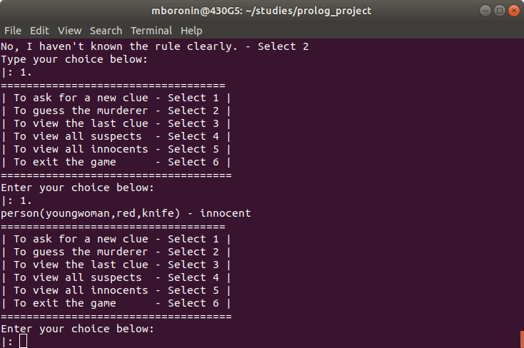

* 1. To guess the murder

When you are ready to guess who the murderer is, here you can make a guess by choosing attributes in age and gender, dress color and weapon respectively.

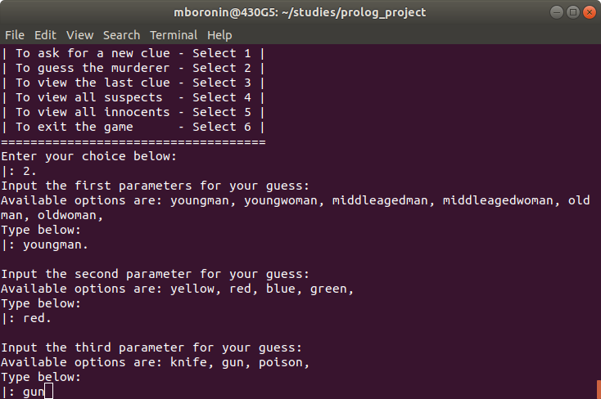

If your guess is right, you win the game.

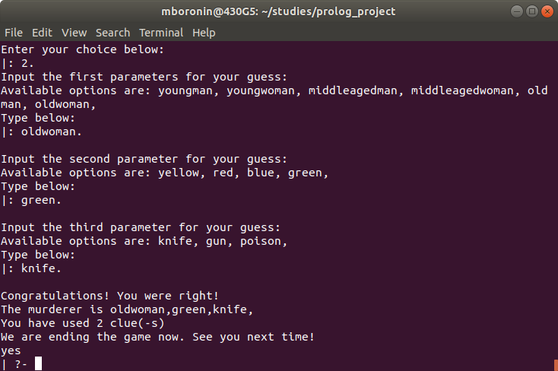

If your guess is wrong, you fail the game.

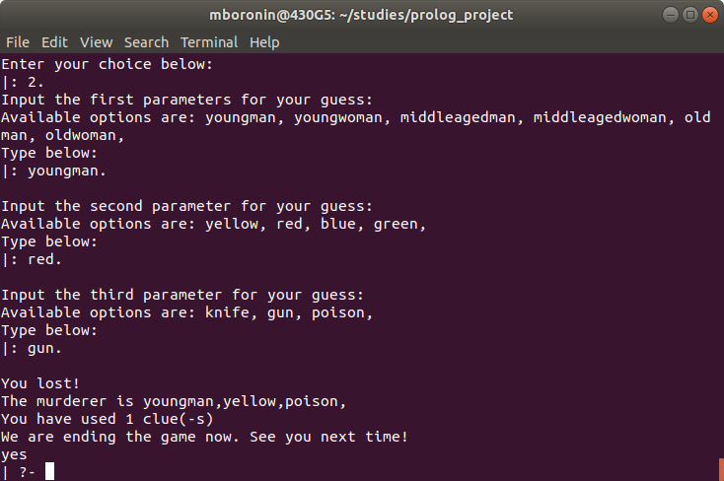

* 1. To view the last clue

You can view the last randomly generated clue, its attributes and role (suspect or innocent).

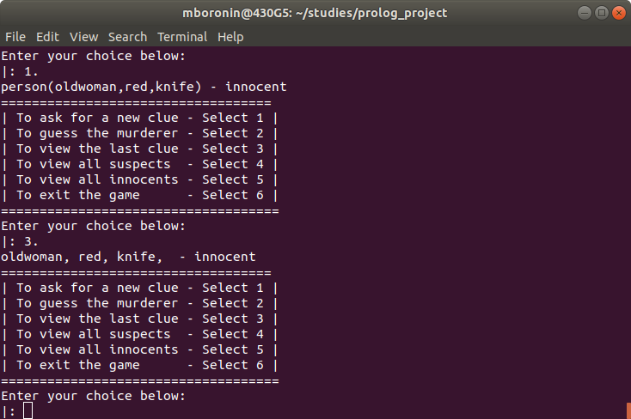

* 1. To view the suspects so far

You can view all the suspects so far.

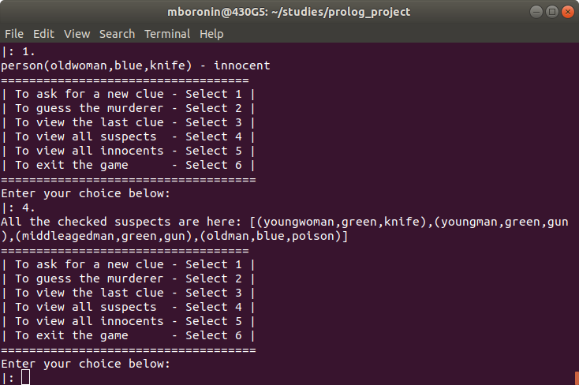

* 1. To view the innocents so far

You can view all the innocents so far.

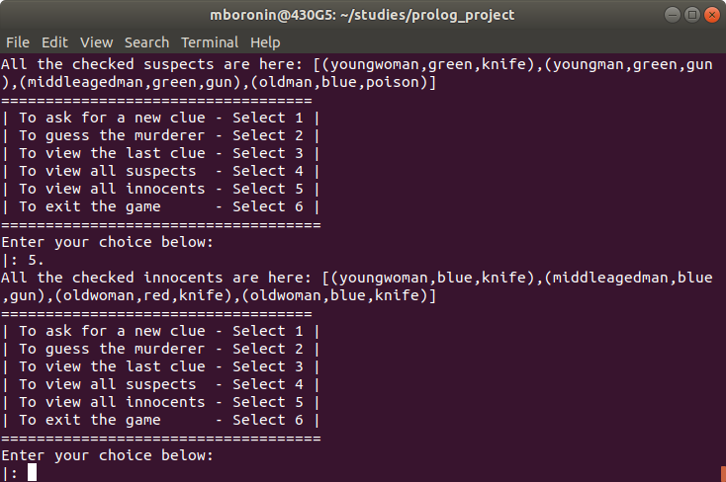

* 1. To exit the game

You can exit the game when you want. And it needs you to restart the game to enter the game again after this operation.

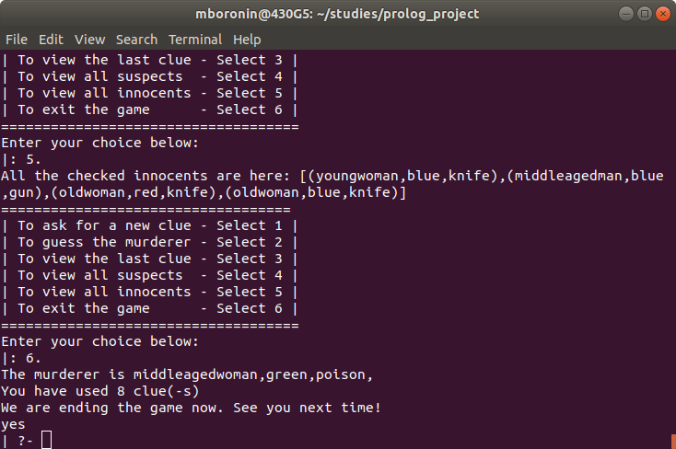

**Errors**

This part explains what kinds of behavior may lead to errors.

* 1. When your choice is not in the selection list, it may contribute to an error. You will be asked to make choice in the selection list.
  2. When you ask to view the last clue at the start of the game.
  3. When you ask to view the suspects so far but the clues you have do not include any suspects.
  4. When you ask to view the innocents so far but the clues you have do not include any innocents.